Software Architecture Document
for
Songify
Version 1.0 approved
Prepared by:
Faizan Shabir 22L-6552 6H
Ahmed Mukhtar 22L-8225 6H
Tahawar Ali 22L-6761 6H

FAST-NUCES
06-04-2025

Architecture Diagram
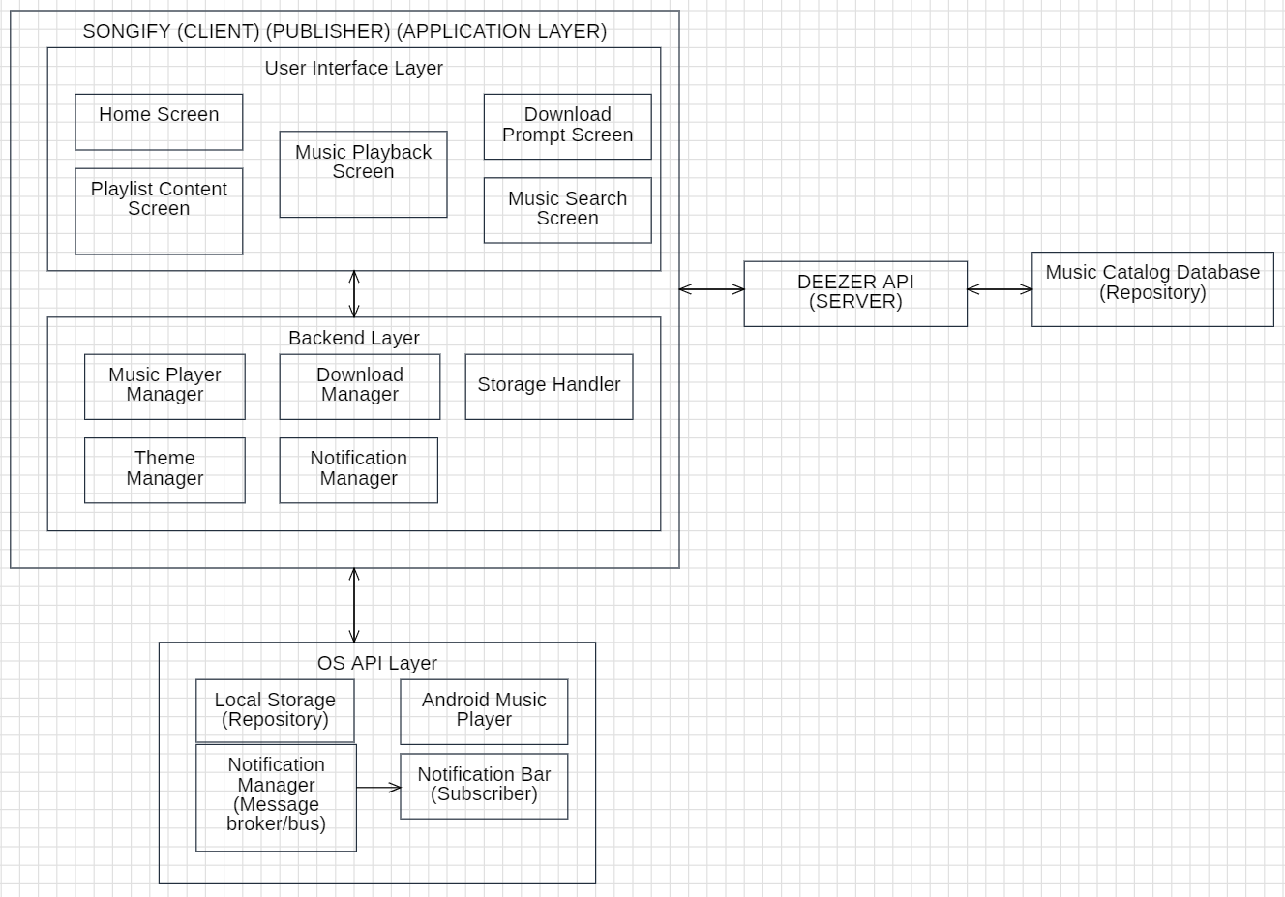
Description
The architecture diagram above does not strictly follow the notations for the different architecture styles because the tool used did not allow those notations and the internet is also filled with different notations.
The architecture styles that suited the android music application were Client-Server, Publish-Subscribe, Repositories, and Layering.
Client-Server style can be observed in the diagram where the application ‘Songify’ is a client and the ‘Deezer API’ used is a server.
Publish-Subscribe style can be observed in the diagram where the application ‘Songify’ is a publisher, the ‘NotificationManager’ provided by the ‘OS API Layer’ is a message broker/bus and ‘Notification Bar’ of the android phone is a subscriber.
Repositories style can be observed in the diagram where the ‘Local Storage’ provided by the ‘OS API Layer’ acts as a repository for the application ‘Songify’ and the ‘Deezer API’ server also has a database that acts as a repository.
Layering style can be observed in the diagram where there is an ‘Application Layer’ (Songify) that uses the services provided by the ‘OS API Layer’. Moreover, there are two sub-layers within the ‘Application Layer’ namely the ‘User Interface Layer’ and the ‘Backend Layer’. Every layer’s services are signified by the small components shown in the form of rectangles within the layer.

Class Diagram
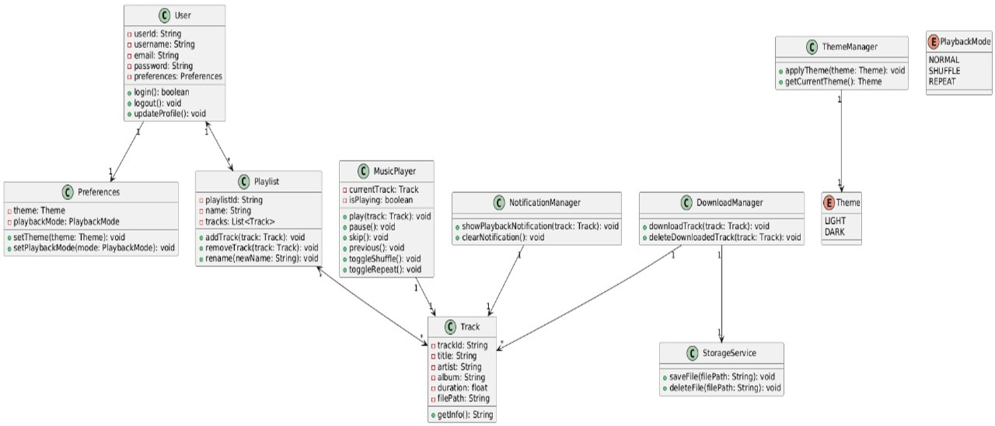
Component Diagram
